

ARBORWOOD COMMUNITY DEVELOPMENT
DISTRICT

LEE COUNTY Regular Board Meeting
September 21, 2026
9:00 A.M.

Special District Services, Inc.
27499 Riverview Center Boulevard, #253 Bonita Springs, FL 33134

www.arborwoodcdd.org 561.630.4922 Telephone 877.SDS.4922 Toll Free 561.630.4923 Facsimile

AGENDA
ARBORWOOD COMMUNITY DEVELOPMENT DISTRICT
Amenity Center Community Room Somerset at the Plantation 10401 Dartington Drive
Fort Myers, Florida, 33913

REGULAR BOARD MEETING
September 21, 2026
9:00 A.M.

- Call to Order
- Proof of Publication… Page 1
- Establish Quorum
- Additions or Deletions to Agenda
- Comments from the Public for Items Not on the Agenda
- Approval of Minutes
  - August 3, 2026 Regular Board Meeting & Public Hearing Minutes… Page 2
- Old Business
- New Business
  - Consider Ratification of Agreement between the District and Woods and Wetlands, Inc
for Exotic Vegetation Maintenance Control… Page 7
  - Consider Approval of Request from Somerset HOA for Tree Removal
  - Consider Request for Gladstone Gate Landscaping… Page 20
  - Consider Resolution No. 2026-06 – Declaring Board Vacancies… Page 27
  - Consider Resolution No. 2026-07 – Resetting a Public Hearing Date for the Revised Rules
of Procedure… Page 29
- Administrative Matters
  - Attorney’s Report
  - Engineer Report
  - Field Inspectors Report – Somerset
  - Preserve Compliance Updates
  - Bridgetown Report… Page 31
  - Manager’s Report
    - Financials… Page 32
    - Next Meeting Date – October 21, 2026
- Board Member Comments
- Adjourn

Publication Date 2026-09-11
Subcategory Miscellaneous Notices

NOTICE OF REGULAR BOARD MEETING
ARBORWOOD COMMUNITY DEVELOPMENT DISTRICT
The Board of Supervisors (the Board) of the Arborwood Community Development District (the District) will hold a Regular Board Meeting (the Meeting) on September 21, 2026, at 9:00 a.m. in the Amenity Center Community Room, Somerset at the Plantation, 10401 Dartington Drive, Fort Myers, Florida 33913. The purpose of the Regular Board Meeting is for the Board to consider any business which may properly come before it.
The Meeting is open to the public and will be conducted in accordance with the provisions of Florida law for community development districts. The Meeting may be continued in progress without additional notice to a time, date, and location stated on the record. A copy of the agenda for the Meeting may be obtained from the Districts website (www.arborwoodcdd.org) or by contacting the District Manager, Special District Services, at (941) 223-2475. There may be occasions when one or more Supervisors will participate by telephone.
Pursuant to provisions of the Americans with Disabilities Act, any person requiring special accommodations to participate in this Meeting is asked to advise the District Office at least forty-eight (48) hours before the Meeting by contacting the District Manager at (561) 630-4922. If you are hearing or speech impaired, please contact the Florida Relay Service at 1 (800) 955-8770, who can aid you in contacting the District Office.
A person who decides to appeal any decision made at the Meeting with respect to any matter considered at the Meeting is advised that person will need a record of the proceedings and that accordingly, the person may need to ensure that a verbatim record of the proceedings is made including the testimony and evidence upon which the appeal is to be based.
Meetings may be cancelled from time to time without advertised notice. District Manager
Arborwood Community Development District www.arborwoodcdd.org
9/11/26 #12614650

Page 1

ARBORWOOD COMMUNITY DEVELOPMENT DISTRICT PUBLIC HEARING & REGULAR BOARD MEETING AUGUST 3, 2026

- CALL TO ORDER

The August 3, 2026, Regular Board Meeting of the Arborwood Community Development District (the “District”) was called to order at 9:00 a.m. in the Amenity Center Community Room of the Somerset at the Plantation located at 10401 Dartington Drive, Fort Myers, Florida 33913.

PROOF OF PUBLICATION

Proof of publication was presented which indicated that notice of the meeting had been published in the Fort Myers News Press on July 14, 2026, and July 21, 2026, as legally required.

ESTABLISH A QUORUM

It was determined that the attendance of the following Supervisors constituted a quorum and it was in order to proceed with the meeting:

Chairman | Jeff Gordish | Present
Vice Chairperson | Karin Hagen | Present via phone
Supervisor | Jack Aycock | Present
Supervisor | Donald Schrotenboer | Present
Supervisor | Christopher Anderson | Present

Staff members in attendance were:

District Manager | Kathleen Meneely | Special District Services, Inc.
General Counsel | Wes Haber (via phone) | Kutak Rock, LLC
District Engineer | Ryan Lorenz | JR Evans Engineering
Field Inspector | Bohdan Hirniak | Special District Services, Inc.

Also present were: Ramsey Fisher of Passarella & Associates and Keith Dombrowski of the Bridgetown Ponds & Preserves Committee.

ADDITIONS OR DELETIONS TO THE AGENDA
There were no additions or deletions to the agenda.

COMMENTS FROM THE PUBLIC FOR ITEMS NOT ON THE AGENDA
There was no public comment.

APPROVAL OF MINUTES

June 15, 2026, Regular Board Meeting

Page 1 of 5

The minutes of the June 15, 2026, Regular Board Meeting were presented for consideration.
A MOTION was then made by Supervisor Gordish, seconded by Supervisor Aycock and passed unanimously approving the minutes of the June 15, 2026, Regular Board Meeting, as presented.

The Regular Board Meeting was then recessed and the Public Hearing was opened.

PUBLIC HEARING

Proof of Publication

Proof of publication was presented which indicated that notice of the Public Hearing had been published in the
Fort Myers News Press on July 14, 2026, and July 21, 2026, as legally required.

Receive Public Comment on Fiscal Year 2026/2027 Final Budget

There was no public comment on the Fiscal Year 2026/2027 Final Budget.

Consider Resolution No. 2026-03 – Adopting a Fiscal Year 2026/2027 Final Budget

Resolution No. 2026-03 was presented, entitled:

RESOLUTION 2026-03
[FY 2026/2027 APPROPRIATION RESOLUTION]
THE ANNUAL APPROPRIATION RESOLUTION OF THE ARBORWOOD COMMUNITY DEVELOPMENT DISTRICT (“DISTRICT”) RELATING TO THE ANNUAL APPROPRIATIONS AND ADOPTING THE BUDGET(S) FOR THE FISCAL YEAR BEGINNING OCTOBER 1, 2026, AND ENDING SEPTEMBER 30, 2027; AUTHORIZING BUDGET AMENDMENTS; AND PROVIDING AN EFFECTIVE DATE.

Ms. Meneely advised that no changes had been made since the Board’s previous review of the proposed budget.
A MOTION was made by Supervisor Schrotenboer, seconded by Supervisor Gordish and passed unanimously adopting Resolution No. 2026-03 adopting the Fiscal Year 2026/2027 Final Budget, as presented.

Consider Resolution No. 2026-04 – Adopting a Fiscal Year 2026/2027 Assessment Roll

Resolution No. 2026-04 was presented, entitled:

RESOLUTION 2026-04
[FY 2026/2027 ASSESSMENT RESOLUTION]

A RESOLUTION OF THE BOARD OF SUPERVISORS OF THE ARBORWOOD COMMUNITY DEVELOPMENT DISTRICT PROVIDING FOR FUNDING FOR THE FY 2026/2027 ADOPTED BUDGET(S); PROVIDING FOR THE COLLECTION AND ENFORCEMENT OF SPECIAL ASSESSMENTS, INCLUDING BUT NOT LIMITED TO PENALTIES AND INTEREST THEREON; CERTIFYING AN ASSESSMENT
Page 2 of 5

ROLL; PROVIDING FOR AMENDMENTS TO THE ASSESSMENT ROLL; PROVIDING A SEVERABILITY CLAUSE; AND PROVIDING AN EFFECTIVE DATE.

Mr. Haber explained that the annual resolution levies the Operations and Maintenance assessments and certifies both the Operations and Maintenance and debt assessments for collection on the annual Lee County tax bill.
A MOTION was made by Supervisor Gordish, seconded by Supervisor Schrotenboer and passed unanimously adopting Resolution No. 2026-04 approving the Fiscal Year 2026/2027 Assessment Roll, as presented.

The Public Hearing was then closed and the Regular Board Meeting was reconvened.

OLD BUSINESS

There were no Old Business items to come before the Board.

NEW BUSINESS

Consider Resolution No. 2026-05 – Adopting a Fiscal Year 2026/2027 Meeting Schedule

Resolution No. 2026-05 was presented, entitled:

RESOLUTION NO. 2026-05
A RESOLUTION OF THE BOARD OF SUPERVISORS OF THE ARBORWOOD COMMUNITY DEVELOPMENT DISTRICT, ESTABLISHING A REGULAR MEETING SCHEDULE FOR FISCAL YEAR 2026/2027 AND SETTING THE TIME AND LOCATION OF SAID DISTRICT MEETINGS; AND PROVIDING AN EFFECTIVE DATE.

Ms. Meneely reviewed the proposed meeting schedule, noting that beginning in October 2026, regular meetings would be held on Wednesdays at 10:00 a.m.
A MOTION was made by Supervisor Gordish, seconded by Supervisor Schrotenboer and passed unanimously adopting Resolution No. 2026-05 approving the Fiscal Year 2026/2027 Meeting Schedule, as presented.

Oak Tree Removal

Mr. Lorenz reviewed two resident requests for oak tree removal at 12832 Epping and 12853 Epping. Discussion focused on maintaining consistency with the District’s policy of cutting trees flush to grade while leaving root systems in place within landscape maintenance easements to minimize soil disturbance. Mr. Lorenz advised that where root damage to improvements is documented, installation of root barriers or limited root removal outside District-maintained areas may be appropriate on a case-by-case basis. The Board also discussed drainage easements, tree removals within District-maintained areas, and the importance of obtaining District approval before removing trees.

No Board action was required on this matter.

Page 3 of 5

ADMINISTRATIVE MATTERS

Attorney’s Report

Mr. Haber had no formal report at this time.

Engineer’s Report

Mr. Lorenz reported that staff continues investigating preserve ponding near Clifton in Bridgetown following recent heavy rainfall and will perform additional inspections to determine whether grading adjustments may be warranted.

Mr. Lorenz also updated the Board regarding Somerset lake bank repairs, noting that Lake Doctors now offers a lifetime warranty on repairs when combined with its lake management program. Additional information and pricing will be obtained for future Board consideration.

Mr. Lorenz further reported on ongoing efforts to address pool overflow erosion areas within Somerset, review swale concerns on Kingsmill, and continue evaluating future lake bank inspections and maintenance needs.

Field Inspector’s Report - Somerset

Mr. Hirniak reported that July rainfall slightly exceeded historical averages while year-to-date rainfall remained below normal. Algae growth observed along portions of the lake edges was discussed and will continue to be monitored. General lake and preserve conditions remain satisfactory.

Preserve Compliance Updates

Mr. Fisher reported that mitigation maintenance activities had been completed and the preserves remained in good overall condition. Ongoing exotic vegetation maintenance will continue as needed.

Discussion followed regarding tree topping requests within preserve areas and the coordination of future proposals with Woods & Wetlands.
A MOTION was made by Supervisor Gordish, seconded by Supervisor Anderson and passed unanimously approving a proposal in an amount not to exceed $2,000 for tree topping and debris removal at 12905 New Market, as presented.

Bridgetown Report

Ms. Meneely reviewed the Bridgetown Report and commended Bridgetown’s property manager for her responsiveness and timely communication with District staff.

Manager’s Report
    - Financials

Ms. Meneely reviewed the financial statements through June, noting the District remained under budget.

By consensus, the Board agreed to cancel the August meeting, with the next regular meeting scheduled for September 21, 2026.
Page 4 of 5

Mr. Haber reviewed the statutory process for Supervisor holdover terms and appointments following the November general election. The Board discussed filling the upcoming vacancy, including obtaining letters of interest from qualified residents before making an appointment.

The Board reached a consensus to first seek interest from residents within the underrepresented communities before issuing a broader announcement regarding the upcoming Board vacancy.

BOARD MEMBER COMMENTS

The Board Members discussed the District’s assessment methodology for parcels located west of Treeline and expressed concerns regarding the proportional allocation of assessments.

Additional discussion was held regarding long-term preserve maintenance, stormwater flow through preserve systems, natural vegetation management, and methods for maintaining preserve performance while complying with environmental permitting requirements.

No Board action was taken on this matter at this time.

ADJOURNMENT
There being no further business to come before the Board, a MOTION was made by Supervisor Gordish, seconded by Supervisor Schrotenboer and passed unanimously adjourning the Regular Board Meeting at 9:50 a.m.

Secretary/Assistant Secretary Chair/Vice-Chair

Page 5 of 5

Agreement Between Arborwood Community Development District
and Woods and Wetlands, Inc. for Exotic Vegetation Maintenance Control

This Agreement (“Agreement”) is made and entered into this day of August, 2026, by and between:

Arborwood Community Development District, a local unit of special-purpose government established pursuant to Chapter 190, Florida Statutes, being situated in Lee County, Florida, and whose mailing address is 27499 Riverview Center Boulevard, Suite #253, Bonita Springs, Florida 34134 (“District”); and

Woods and Wetlands, Inc., a Florida corporation, whose mailing address is 18731 Durrance Road, North Fort Myers, Florida 33917 (hereinafter "Contractor", together with District the “Parties”).

RECITALS

Whereas, the District was established for the purpose of planning, financing, constructing, operating and/or maintaining certain infrastructure; and

Whereas, the District desires to retain an independent contractor to provide exotic vegetation maintenance control services for lands within the District as further identified in this Agreement; and

WHEREAS, Contractor represents that it is qualified to serve as an exotic vegetation maintenance contractor and has agreed to provide to the District those services as further described in Exhibit A, the Scope of Services attached hereto, and incorporated herein (“Services”); and

Whereas, the District finds that entering into this Agreement with Contractor to provide the Services is in the best interest of the District.

Now, therefore, in consideration of the mutual covenants contained in this Agreement, it is agreed that the Contractor is hereby retained, authorized, and instructed by the District to perform in accordance with the following covenants and conditions, which both the District and the Contractor have agreed upon:
  - Incorporation of Recitals. The recitals stated above are true and correct and by this reference are incorporated herein as a material part of this Agreement.

Description of Work and Services.

- The District desires that the Contractor provide the Services within presently accepted standards. Upon all parties executing this Agreement, the Contractor shall provide the District with the Services as set forth in this Agreement.

- While providing the Services, the Contractor shall assign such staff as may be required, and such staff shall be responsible for coordinating, expediting, and controlling all aspects to assure completion of the Services.
- The Contractor shall provide the specific professional services as shown in Paragraph 3 of this Agreement.
  - SCOPE OF EXOTIC VEGETATION MAINTENANCE CONTROL SERVICES. The
duties, obligations, and responsibilities of the Contractor are those described in the Proposals attached hereto as Exhibit A. Contractor shall solely be responsible for the means, manner and methods by which its duties, obligations and responsibilities are met to the satisfaction of the District. Contractor shall be responsible to determine when it should perform the exotic vegetation treatment event and such timing shall be selected to maximize the Services. Contractor acknowledges that the Services are being provided to comply with the District’s water management district permit and/or Army Corp of Engineer permit and that the Services shall be provided in accordance with such permits. When applicable under the permits referenced in the immediate preceding sentence, Contractor agrees that the Services shall result in: 1) no exotic or nuisance plant species of seed bearing size (greater than three feet in height) remaining in the treated area; and 2) exotic or nuisance plant species smaller than seed bearing size shall occupy no more than two percent cover in any individual stratum and no more than four percent of the total plant growth in the treated area after the exotic vegetation treatment event. Contractor shall be required to provide whatever amount of time and materials it may require to attain the above-described results. Additionally, Contractor shall use hand removal to perform the exotic treatment event using one or more of the following methods: (1) cut exotics within 12 inches of ground elevation and treat remaining stump with approved herbicide; (2) foliar application of approved herbicide to exotic tree saplings; and/or (3) foliar application of approved herbicide or hand pulling of herbaceous exotics and/or seedlings.
  - Manner of Contractor’s Performance. The Contractor agrees, as an independent contractor, to undertake work and/or perform or have performed the Services as specified in this Agreement or any addendum executed by the Parties or in any authorized written work order by the District issued in connection with this Agreement and accepted by the Contractor. All work shall be performed in a neat and professional manner reasonably acceptable to the District and shall be in accordance with industry standards. The performance of all services by the Contractor under this Agreement and related to this Agreement shall conform to any written instructions issued by the District.
- Should any work and/or services be required which are not specified in this Agreement or any addenda, but which are nevertheless necessary for the proper provision of services to the District, such work or services shall be fully performed by the Contractor as if described and delineated in this Agreement.

2

- This Agreement grants to Contractor the right to enter the lands that are subject to this Agreement, for those purposes described in this Agreement, and Contractor hereby agrees to comply with all applicable laws, rules, and regulations.

- The District Manager and the District’s Field Inspector shall act as the District’s representative with respect to the Services. The District’s representative shall have complete authority to transmit instructions, receive information, interpret and define the District’s policies and decisions with respect to materials, equipment, elements, and systems pertinent to the Services.
- Contractor shall perform the Services in a neat and workmanlike manner. In the event the District in its sole determination, finds that the work of Contractor is not satisfactory to District, District shall have the right to immediately terminate this Agreement and will only be responsible for payment of work satisfactorily completed and for materials actually incorporated into the Services.
- Contractor shall use all due care to protect the property of the District, its residents, and landowners from damage. Contractor agrees to repair any damage resulting from Contractor’s activities and work within twenty-four
(24) hours.

Compensation and Payment.

- As compensation for the Services described in this Agreement, the District agrees to pay the Contractor the annual 2027 payment of $9,000.00 for the Project described as “Arborwood Preserve (fka Parcel C) – Preserve Maintenance,” and the annual payments for 2027, 2028, and 2029 in the amount of $37,900 per year for the Project described as “Somerset at The Plantation – Invasive Vegetation Maintenance” as further described on Exhibit A. Contractor shall invoice the District for the Services upon completion of the Services and acceptance by the District. The District shall provide payment within forty-five (45) days of receipt of an invoice. Such amounts include all materials and labor provided for in Exhibit A and all items, labor, materials, or otherwise, to provide the District the maximum benefits of the Services.
- If the District should desire additional work or services, or to add additional lands to be maintained, the Contractor agrees to negotiate in good faith to undertake such additional work or services in accordance with the prices set forth in Exhibit A. Upon successful negotiations, the Parties shall agree in writing to an addendum, addenda, or change order(s) to this Agreement. The Contractor shall be compensated for such agreed

3

additional work or services based upon a payment amount acceptable to the Parties and agreed to in writing.

Additional services not included in the Scope of Services can be provided by the Contractor. However, no additional services shall be provided by the Contractor unless done at the written direction of the District. Fees for such additional services shall be as provided for in the attached Price Quotation, or, if not identified, as negotiated between the District and the Contractor.
- The District may require, as a condition precedent to making any payment to the Contractor, that all subcontractors, materialmen, suppliers or laborers be paid and require evidence, in the form of Lien Releases or partial Waivers of Lien, to be submitted to the District by those subcontractors, materialmen, suppliers or laborers, and further require that the Contractor provide an Affidavit relating to the payment of said indebtedness. Further, the District shall have the right to require, as a condition precedent to making any payment, evidence from the Contractor, in a form satisfactory to the District, that any indebtedness of the Contractor, as to the Services, has been paid and that the Contractor has met all of the obligations with regard to the withholding and payment of taxes, Social Security payments, Worker’s Compensation, Unemployment Compensation contributions, and similar payroll deductions from the wages of employees.

Insurance.

- The Contractor shall maintain throughout the term of this Agreement the following insurance:
  - Worker’s Compensation Insurance in accordance with the laws of the State of Florida.
  - Commercial General Liability Insurance covering the Contractor’s legal liability for bodily injuries, with limits of not less than
$1,000,000 combined single limit bodily injury and property damage liability, and covering at least the following hazards:
    - Independent Contractors Coverage for bodily injury and property damage in connection with subcontractors’ operation.
  - Employer’s Liability Coverage with limits of at least $1,000,000 (one million dollars) per accident or disease.

4

  - Automobile Liability Insurance for bodily injuries in limits of not less than $1,000,000 combined single limit bodily injury and for property damage, providing coverage for any accident arising out of or resulting from the operation, maintenance, or use by the Contractor of any owned, non-owned, or hired automobiles, trailers, or other equipment required to be licensed.
- The District, its staff, consultants, agents and supervisors shall be named as additional insureds and certificate holders. The Contractor shall furnish the District with the Certificate of Insurance evidencing compliance with this requirement. No certificate shall be acceptable to the District unless it provides that any change or termination within the policy periods of the insurance coverage, as certified, shall not be effective within thirty (30) days of prior written notice to the District. Insurance coverage shall be from a reputable insurance carrier, licensed to conduct business in the State of Florida, and such carrier shall have a Best’s Insurance Reports rating of at least A-VII.
- If the Contractor fails to have secured and maintained the required insurance, the District has the right (without any obligation to do so, however), to secure such required insurance in which event, the Contractor shall pay the cost for that required insurance and shall furnish, upon demand, all information that may be required in connection with the District’s obtaining the required insurance.

Indemnification.

- Obligations under this section shall include the payment of all settlements, judgments, damages, liquidated damages, penalties, forfeitures, back pay awards, court costs, arbitration and/or mediation costs, litigation expenses, attorney fees, and paralegal fees (incurred in court, out of court, on appeal, or in bankruptcy proceedings) as ordered.
- Contractor agrees to indemnify and hold harmless the District and its officers, agents and employees from any and all liability, claims, actions, suits or demands by any person, corporation or other entity for injuries, death, property damage or of any nature, arising out of, or in connection with, the work to be performed by Contractor. Contractor further agrees that nothing herein shall constitute or be construed as a waiver of the District's limitations on liability contained in Section 768.28, Florida Statutes, or other statute. Any subcontractor retained by the Contractor shall acknowledge in writing such subcontractor’s acceptance of the terms of this Section 7.

  - Compliance with Governmental Regulation. The Contractor shall keep, observe, and perform all requirements of applicable local, State, and Federal laws, rules,

5

regulations, or ordinances. If the Contractor fails to notify the District in writing within five (5) days of the receipt of any notice, order, required to comply notice, or a report of a violation or an alleged violation, made by any local, State, or Federal governmental body or agency or subdivision thereof with respect to the Services or any action of the Contractor or any of its agents, servants, employees, or materialmen, or with respect to terms, wages, hours, conditions of employment, safety appliances, or any other requirements applicable to provision of the Services, or fails to comply with any requirement of such agency within five (5) days after receipt of any such notice, order, request to comply notice, or report of a violation or an alleged violation, the District may terminate this Agreement, such termination to be effective immediately upon the giving of notice of termination.
  - LIENS AND CLAIMS. The Contractor shall promptly and properly pay for all labor employed, materials purchased, and equipment hired by it to perform under this Agreement. The Contractor shall keep the District’s property free from any materialmen’s or mechanic’s liens and claims or notices in respect to such liens and claims, which arise by reason of the Contractor’s performance under this Agreement, and the Contractor shall immediately discharge any such claim or lien. In the event that the Contractor does not pay or satisfy such claim or lien within three (3) business days after the filing of notice thereof, the District, in addition to any and all other remedies available under this Agreement, may terminate this Agreement to be effective immediately upon the giving of notice of termination.

Default and Protection Against Third Party Interference. A default
by either Party under this Agreement shall entitle the other to all remedies available at law or in equity, which may include, but not be limited to, the right of damages, injunctive relief, and/or specific performance. The District shall be solely responsible for enforcing its rights under this Agreement against any interfering third party. Nothing contained in this Agreement shall limit or impair the District’s right to protect its rights from interference by a third party to this Agreement.

  - CUSTOM AND USAGE. It is hereby agreed, any law, custom, or usage to the contrary notwithstanding, that the District shall have the right at all times to enforce the conditions and agreements contained in this Agreement in strict accordance with the terms of this Agreement, notwithstanding any conduct or custom on the part of the District in refraining from so doing; and further, that the failure of the District at any time or times to strictly enforce its rights under this Agreement shall not be construed as having created a custom in any way or manner contrary to the specific conditions and agreements of this Agreement, or as having in any way modified or waived the same.

  - SUCCESSORS. This Agreement shall inure to the benefit of and be binding upon the heirs, executors, administrators, successors, and assigns of the Parties to this Agreement, except as expressly limited in this Agreement.

  - TERMINATION. The District agrees that the Contractor may terminate this Agreement with cause by providing thirty (30) days written notice of termination to the District; provided, however, that the District shall be provided a reasonable opportunity to cure any failure under this Agreement; and that the Contractor may terminate this Agreement for any

6

reason by providing ninety (90) days written notice of termination to the District. The Contractor agrees that the District may terminate this Agreement immediately with cause by providing written notice of termination to the Contractor. The District may terminate this Agreement without cause by providing thirty (30) days written notice of termination to the Contractor. Upon any termination of this Agreement, the Contractor shall be entitled to payment for all work and/or services rendered up until the effective termination of this Agreement, subject to whatever claims or off-sets the District may have against the Contractor.
  - PERMITS AND LICENSES. All permits and licenses required by any governmental agency directly for the District shall be obtained and paid for by the District. All other permits or licenses necessary for the Contractor to perform under this Agreement shall be obtained and paid for by the Contractor.

  - ASSIGNMENT. Neither the District nor the Contractor may assign this Agreement without the prior written approval of the other. Any purported assignment without such written approval shall be void.

  - INDEPENDENT CONTRACTOR STATUS. In all matters relating to this Agreement, the Contractor shall be acting as an independent contractor. Neither the Contractor nor employees of the Contractor, if there are any, are employees of the District under the meaning or application of any Federal or State Unemployment or Insurance Laws or Old Age Laws or otherwise. The Contractor agrees to assume all liabilities or obligations imposed by any one or more of such laws with respect to employees of the Contractor, if there are any, in the performance of this Agreement. The Contractor shall not have any authority to assume or create any obligation, express or implied, on behalf of the District and the Contractor shall have no authority to represent the District as an agent, employee, or in any other capacity, unless otherwise set forth in this Agreement.

  - Headings for Convenience Only. The descriptive headings in this Agreement are for convenience only and shall neither control nor affect the meaning or construction of any of the provisions of this Agreement.

  - Enforcement of Agreement. In the event that either the District or the Contractor is required to enforce this Agreement by court proceedings or otherwise, then the substantially prevailing party shall be entitled to recover all fees and costs incurred, including reasonable attorneys’ fees, paralegal fees and costs for trial, alternative dispute resolution, or appellate proceedings.
  - AGREEMENT. This instrument, together with its Exhibit, shall constitute the final and complete expression of this Agreement between the District and the Contractor relating to the subject matter of this Agreement.

  - AMENDMENTS. Amendments to and waivers of the provisions contained in this Agreement may be made only by an instrument in writing which is executed by both the District and the Contractor.

7

  - AUTHORIZATION. The execution of this Agreement has been duly authorized by the appropriate body or official of the District and the Contractor, both the District and the Contractor have complied with all the requirements of law, and both the District and the Contractor have full power and authority to comply with the terms and provisions of this instrument.

  - NOTICES. All notices, requests, consents and other communications under this Agreement ("Notices") shall be in writing and shall be delivered, mailed by First Class Mail, postage prepaid, or overnight delivery service, to the parties, as follows:
- If to the District: Arborwood Community Development District
27499 Riverview Center Blvd., #253 Bonita Springs, Florida 34134
Attn: District Manager

With a copy to: Kutak Rock LLP
107 West College Avenue Tallahassee, Florida 32301 Attn: Wesley S. Haber

If to the Contractor:
Woods and Wetlands, Inc. 18731 Durrance Road
North Fort Myers, FL 33917 Attn:

Except as otherwise provided in this Agreement, any Notice shall be deemed received only upon actual delivery at the address set forth above. Notices delivered after 5:00 p.m. (at the place of delivery) or on a non-business day, shall be deemed received on the next business day. If any time for giving Notice contained in this Agreement would otherwise expire on a non-business day, the Notice period shall be extended to the next succeeding business day. Saturdays, Sundays, and legal holidays recognized by the United States government shall not be regarded as business days. Counsel for the District and counsel for the Contractor may deliver Notice on behalf of the District and the Contractor. Any party or other person to whom Notices are to be sent or copied may notify the other parties and addressees of any change in name or address to which Notices shall be sent by providing the same on five (5) days written notice to the parties and addressees set forth herein.
  - Third Party Beneficiaries. This Agreement is solely for the benefit of the District and the Contractor and no right or cause of action shall accrue upon or by reason, to or for the benefit of any third party not a formal party to this Agreement. Nothing in this Agreement expressed or implied is intended or shall be construed to confer upon any person or corporation other than the District and the Contractor any right, remedy, or claim under or by reason of this Agreement or any of the provisions or conditions of this Agreement; and all of the provisions, representations, covenants, and conditions contained in this Agreement shall inure to the sole benefit of and shall be binding upon the District and the Contractor and their respective representatives, successors, and assigns.

8

  - CONTROLLING LAW; VENUE. This Agreement and the provisions contained in this Agreement shall be construed, interpreted, and controlled according to the laws of the State of Florida. Venue for any dispute shall be in a court of appropriate jurisdiction in Lee County, Florida.

  - COMPLIANCE WITH PUBLIC RECORDS LAWS. Contractor understands and agrees that all documents of any kind provided to the District in connection with this Agreement may be public records, and, accordingly, Contractor agrees to comply with all applicable provisions of Florida law in handling such records, including but not limited, to Section 119.0701, Florida Statutes. Among other requirements and to the extent applicable by law, Contractor shall 1) keep and maintain public records required by the District to perform the service; 2) upon request by the Public Records Custodian, provide the District with the requested public records or allow the records to be inspected or copied within a reasonable time period at a cost that does not exceed the cost provided in Chapter 119, Florida Statutes; 3) ensure that public records which are exempt or confidential, and exempt from public records disclosure requirements, are not disclosed except as authorized by law for the duration of the contract term and following the contract term if Contractor does not transfer the records to the Public Records Custodian of the District; and 4) upon completion of the contract, transfer to the District, at no cost, all public records in Contractor’s possession or, alternatively, keep, maintain and meet all applicable requirements for retaining public records pursuant to Florida laws. When such public records are transferred by Contractor, Contractor shall destroy any duplicate public records that are exempt or confidential and exempt from public records disclosure requirements. All records stored electronically must be provided to the District in a format that is compatible with Microsoft Word or Adobe PDF formats. Contractor acknowledges that the designated Public Records Custodian for the District is Kathleen Meneely.

IF CONTRACTOR HAS QUESTIONS REGARDING THE APPLICATION OF CHAPTER 119, FLORIDA STATUTES, TO CONTRACTOR’S DUTY TO PROVIDE PUBLIC RECORDS RELATING TO THIS CONTRACT, CONTACT THE CUSTODIAN OF PUBLIC RECORDS AT 2501A BURNS ROAD, PALM BEACH GARDENS, FLORIDA 33410; (941) 875-
4195; KMENEELY@SDSINC.ORG.
  - SEVERABILITY. The invalidity or unenforceability of any one or more provisions of this Agreement shall not affect the validity or enforceability of the remaining portions of this Agreement, or any part of this Agreement not held to be invalid or unenforceable.

  - Arm’s Length Transaction. This Agreement has been negotiated fully between the District and the Contractor as an arm's length transaction. The District and the Contractor participated fully in the preparation of this Agreement with the assistance of their respective counsel. In the case of a dispute concerning the interpretation of any provision of this Agreement, the parties are each deemed to have drafted, chosen, and selected the language, and any doubtful language will not be interpreted or construed against any party.

9

  - COUNTERPARTS. This Agreement may be executed in any number of counterparts, each of which when executed and delivered shall be an original; however, all such counterparts together shall constitute, but one and the same instrument.
  - E-VERIFY. The Contractor shall comply with and perform all applicable provisions of Section 448.095, Florida Statutes. Accordingly, to the extent required by Florida Statute, Contractor shall register with and use the United States Department of Homeland Security’s E-Verify system to verify the work authorization status of all newly hired employees. The District may terminate this Agreement immediately for cause if there is a good faith belief that the Contractor has knowingly violated Section 448.091, Florida Statutes. By entering into this Agreement, the Contractor represents that no public employer has terminated a contract with the Contractor under Section 448.095(2)(c), Florida Statutes, within the year immediately preceding the date of this Agreement.

  - COMPLIANCE WITH SECTION 20.055, FLORIDA STATUTES. The Contractor
agrees to comply with Section 20.055(5), Florida Statutes, to cooperate with the inspector general in any investigation, audit, inspection, review, or hearing pursuant such section and to incorporate in all subcontracts the obligation to comply with Section 20.055(5), Florida Statutes.

  - Scrutinized Companies Statement. Contractor certifies that it is not in violation of section 287.135, Florida Statutes, and is not prohibited from doing business with the District under Florida law, including but not limited to Scrutinized Companies with Activities in Sudan List or Scrutinized Companies with Activities in the Iran Petroleum Energy Sector List. If Contractor is found to have submitted a false statement, has been placed on the Scrutinized Companies with Activities in Sudan List or the Scrutinized Companies with Activities in the Iran Petroleum Energy Sector List, or has been engaged in business operations in Cuba or Syria, or is now or in the future on the Scrutinized Companies that Boycott Israel List, or engaged in a boycott of Israel, the District may immediately terminate this Agreement.

[REMAINDER OF PAGE LEFT INTENTIONALLY BLANK]

10

I WITNE WHEREOF, the partie execute this agreement the day and year first written
above.

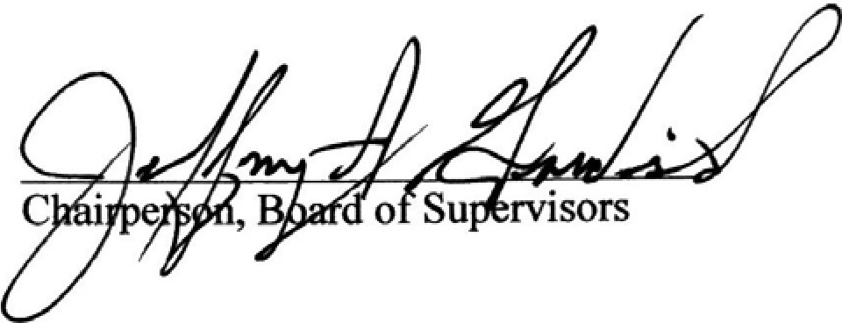
ATT S ARBORWOOD COMMUNITY DEVELOPMENT DISTRICT

Secretary/ Assistant Secretary

WOODS AND WETLANDS, INC., a Florida
corporation

By:07 0'J?1uua,
By: Its:_P_r_es_id_e_n_t _

EXHIBIT A: Scope of Services

11

Exhibit A Scope of Services
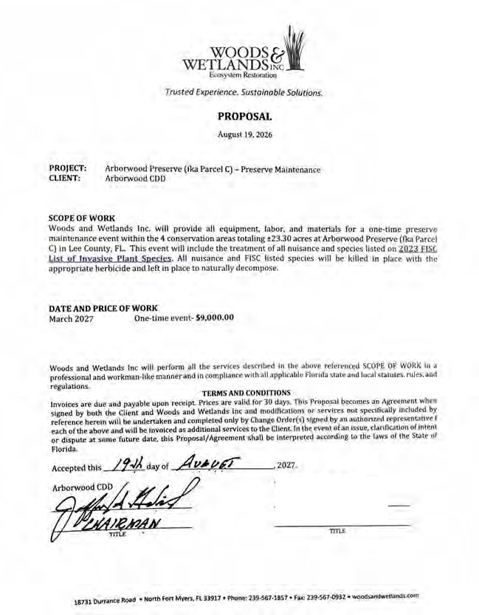
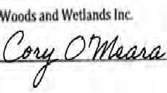

12

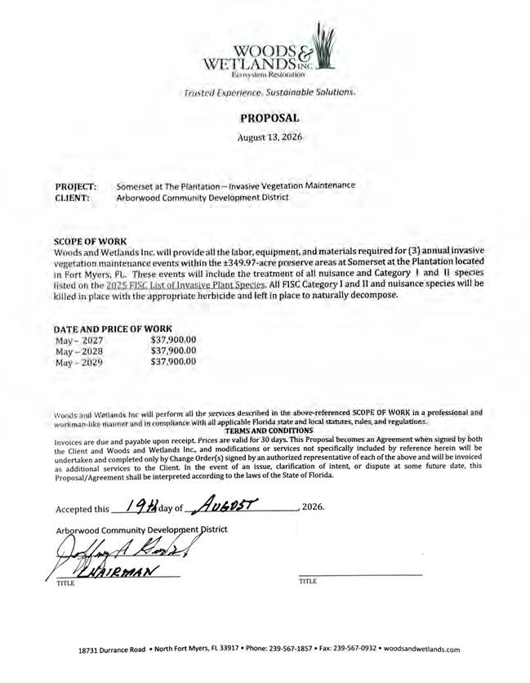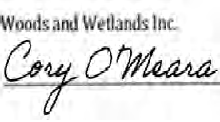

13



Gladstone Gate Enhancement Project
Proposed Work within CDD Property:
- We will remove all Mexican Petunia and Juniper along the entry and exit side of Gladstone.
- We will install new Floratam sod in these areas to help close in the existing beds.
- We will remove the Podocarpus in between Clusia hedges.
- We will install new 15 gallon Clusia shrubs, in the area where Podocarpus was removed, to connect to existing Clusia hedge to have a continuous row of Clusia for increased privacy.
- On the entry and exit sides of Gladstone Way, we will ﬂush cut and stump grind 2 Oak trees and replace with ﬁeld grown Triple Christmas Palms.
Proposed Work with the ROW:
- At each entry and exit monument sign, we will remove existing Purple Queen in the raised planters and Juniper in the lower bed.
- We will then install 1 gallon Variegated Lirope in the raised beds and 3 gallon Red Bougainvillea shrubs in the lower beds.
- In the center island, leading to the guard house, we will remove all Juniper, Ligustrum, Bird of Paradise and Variegated Arboricolas.
- We will then install a row of 7 gallon Cocoplums down the center of the island, in between the palm trees. Three gallon Ruby Chinensis Lorapetalums will be installed in a staggered pattern, in groups of six, on either side of the Cocoplums. 7 gallon Blue Agave will be installed in between the groupings of Lorapetalums (6 on each side of the island).
- After installation is complete, we will install fresh Pine Straw in the beds.
- Once the project is oficially approved, we will start the project within 7 – 10 business days.




Gladstone Way Gate

Renderings

July, 2026




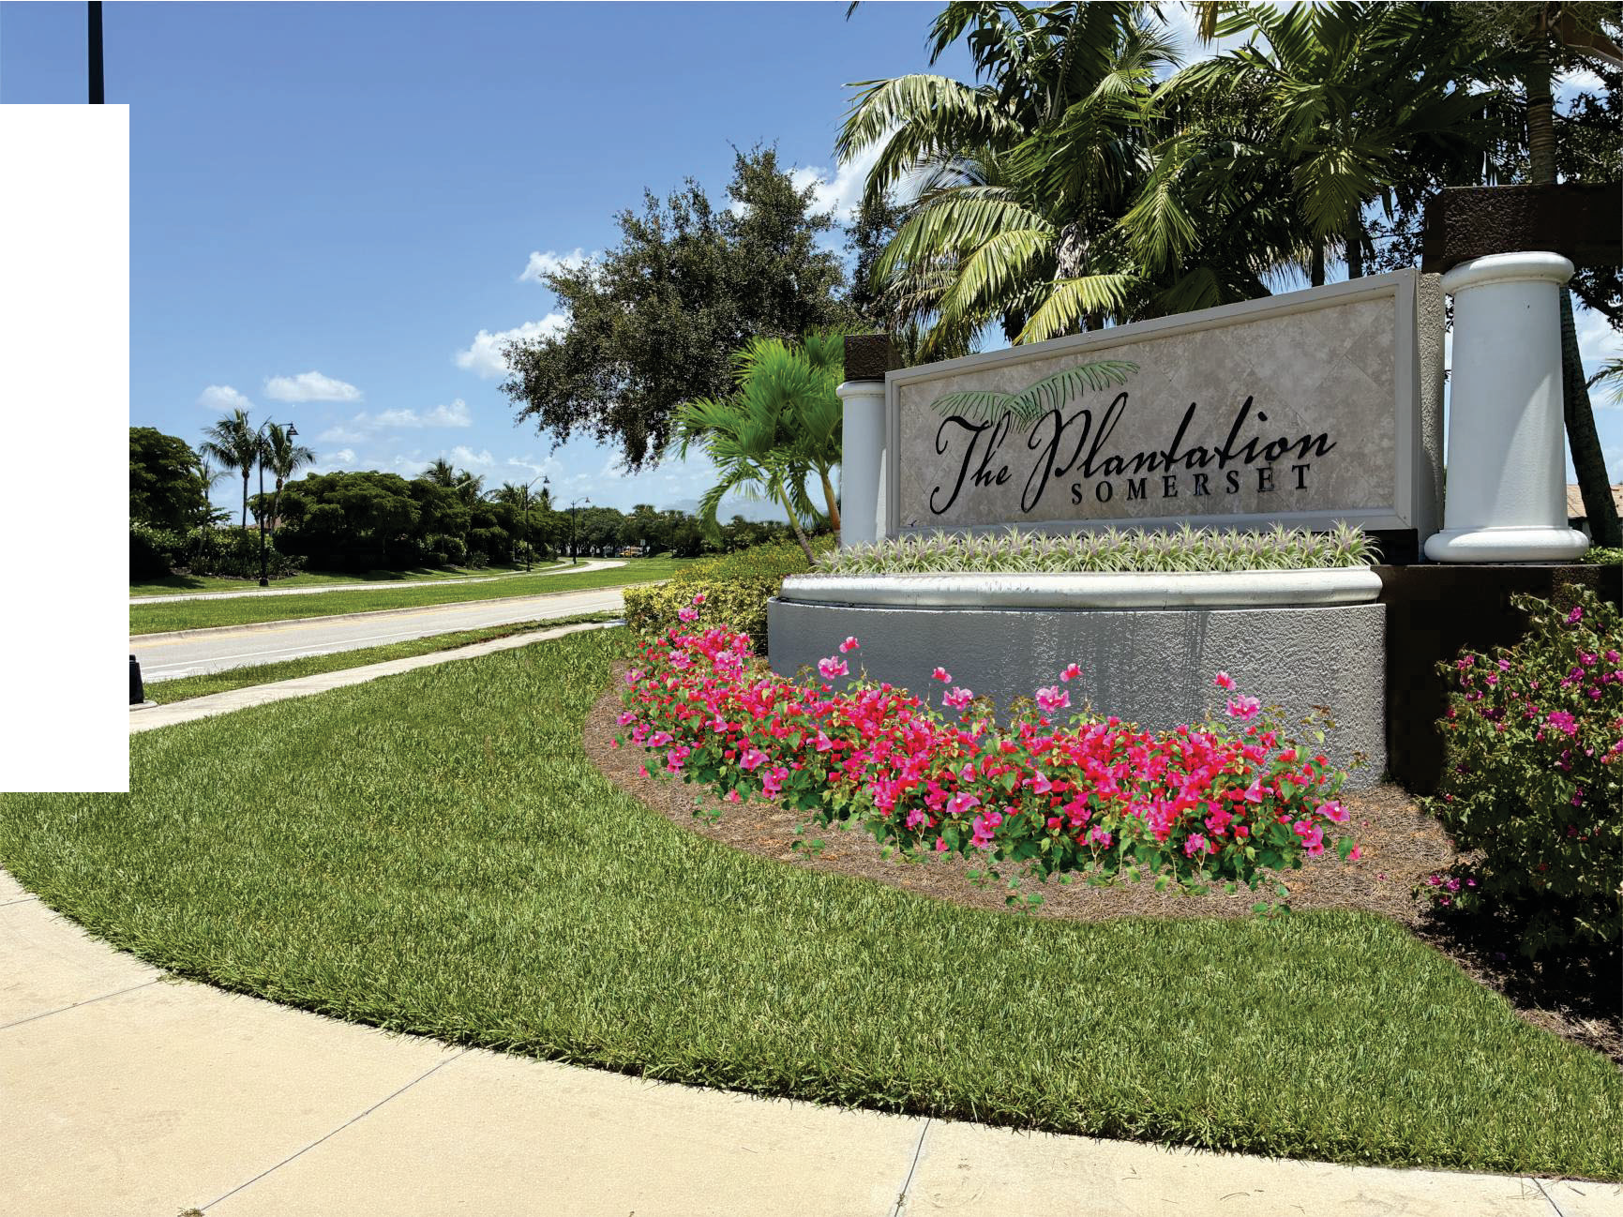

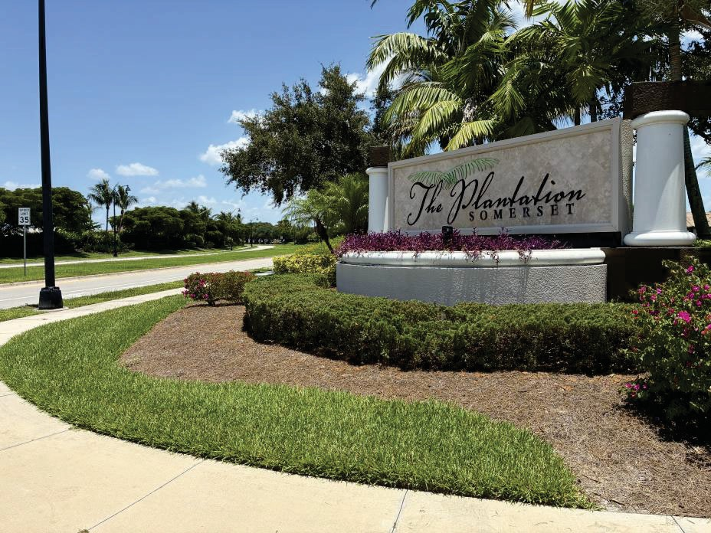
Left Monument

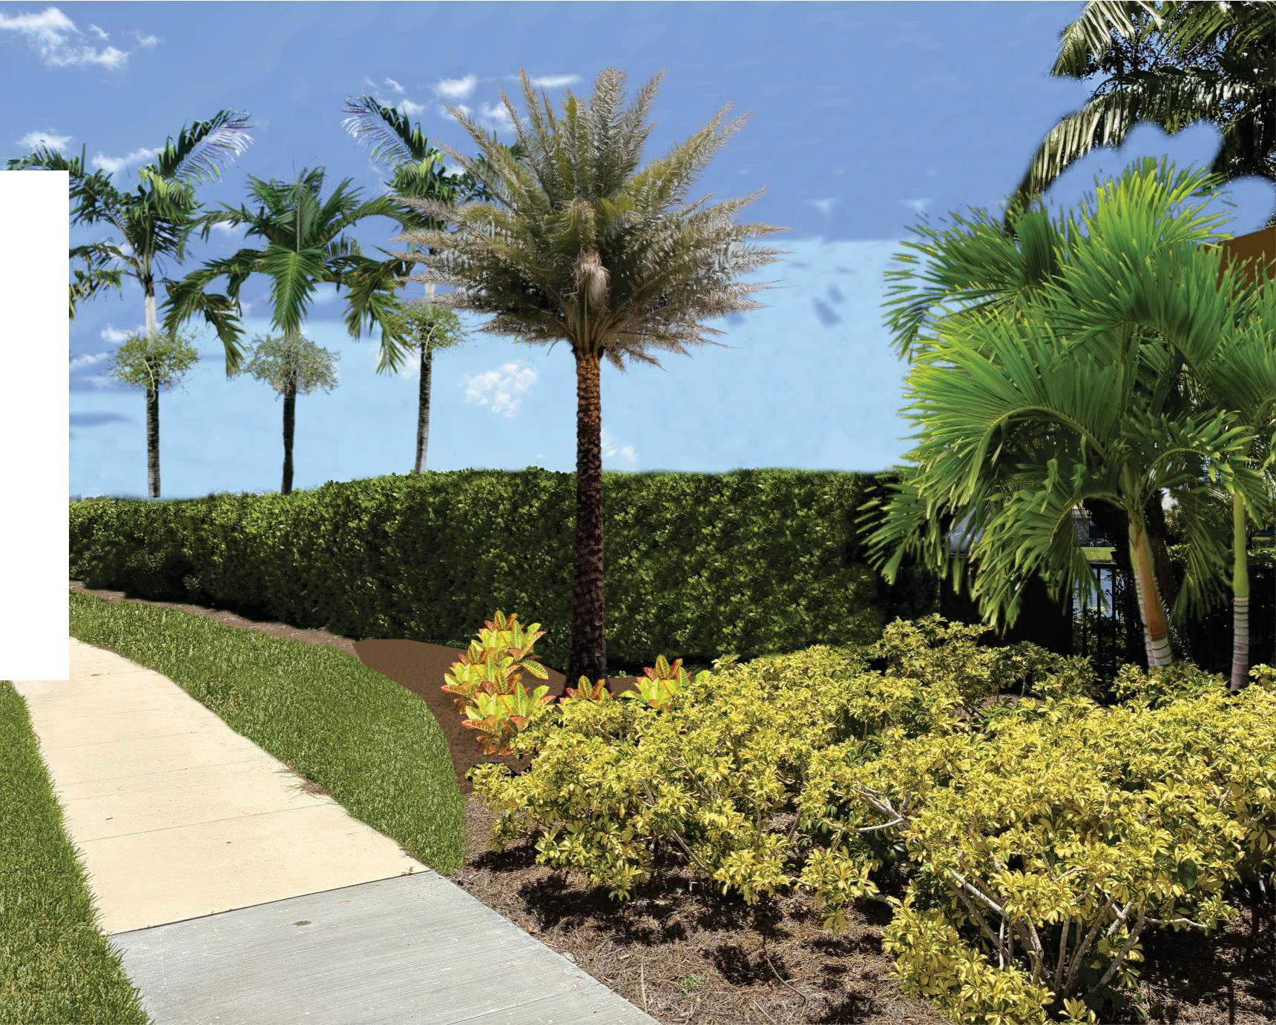

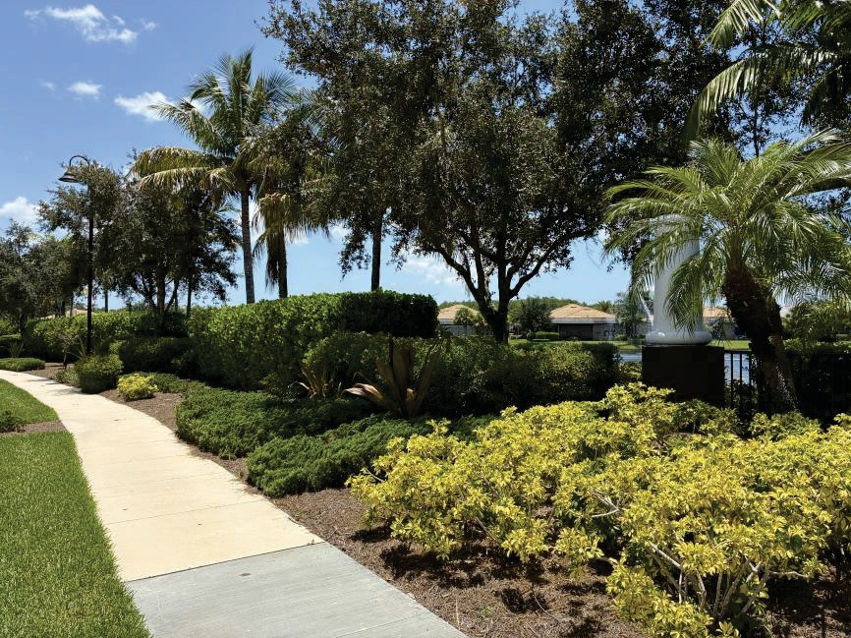
Hedge Line

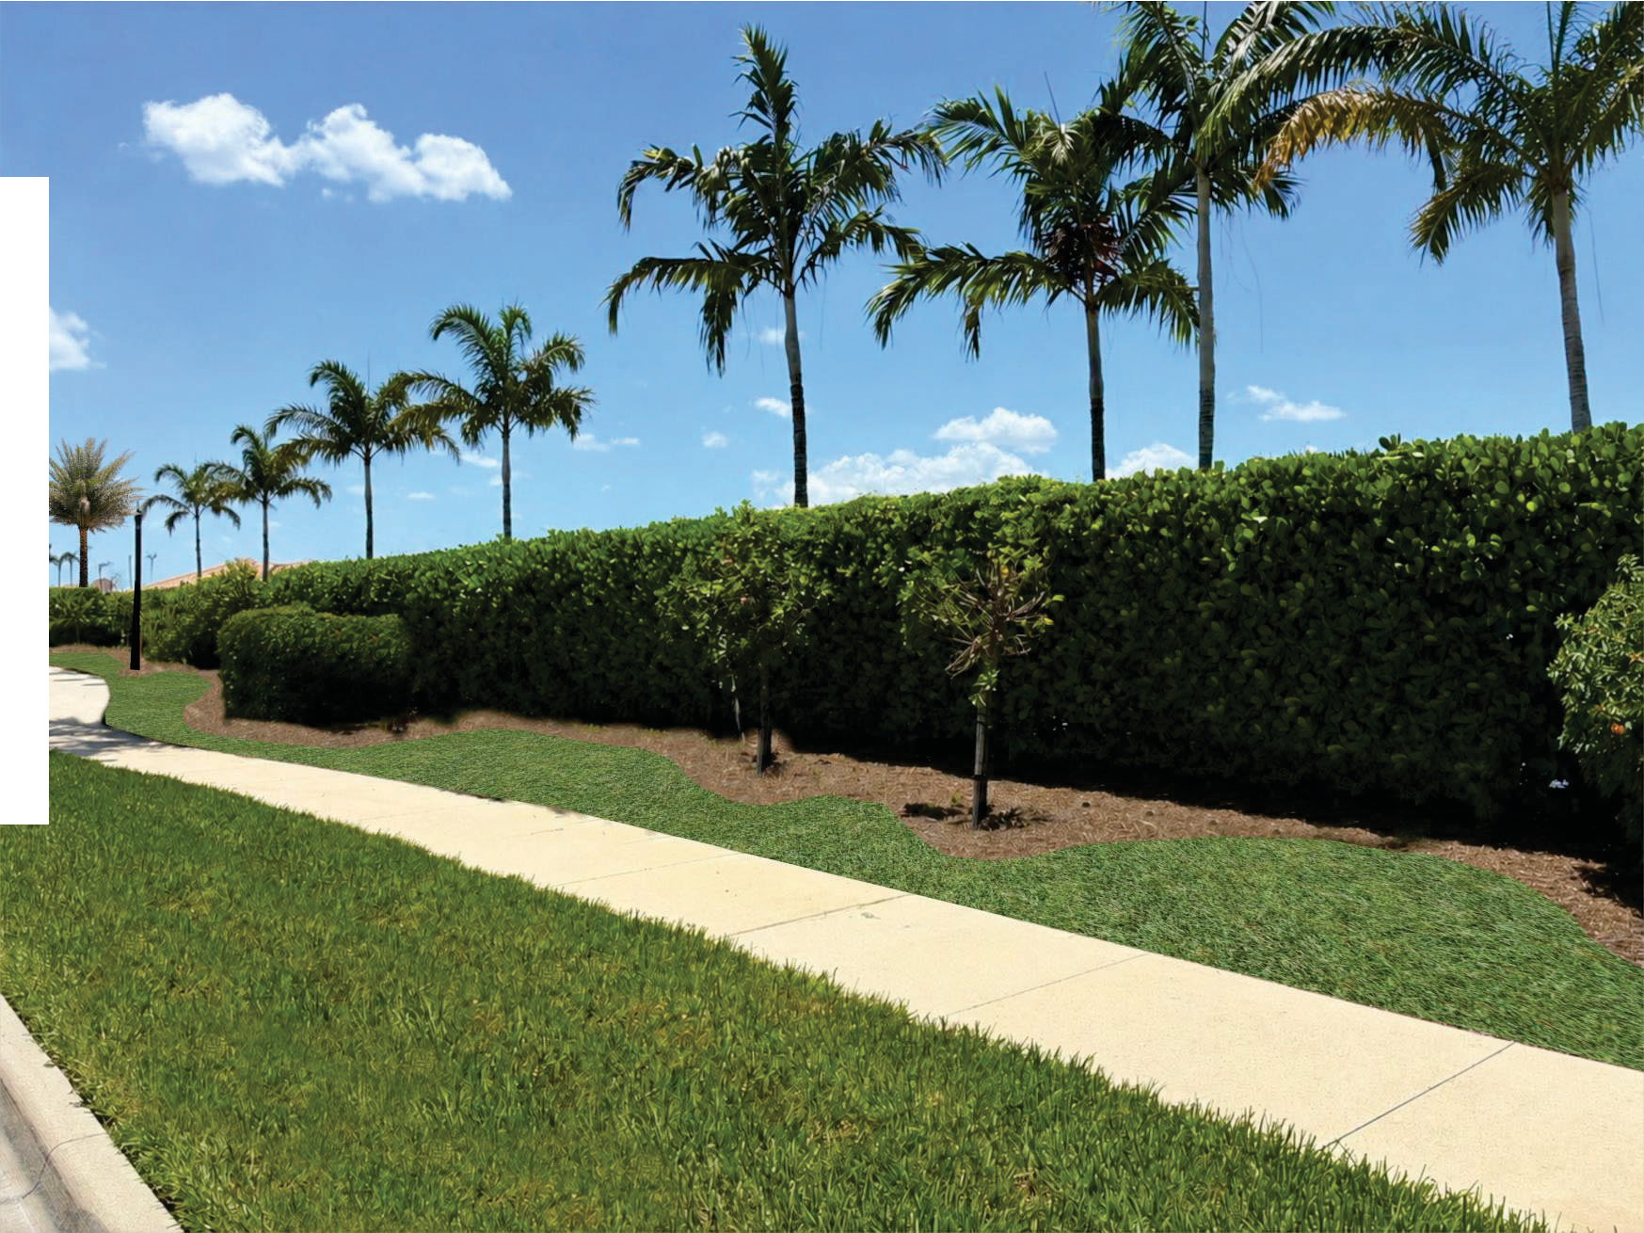

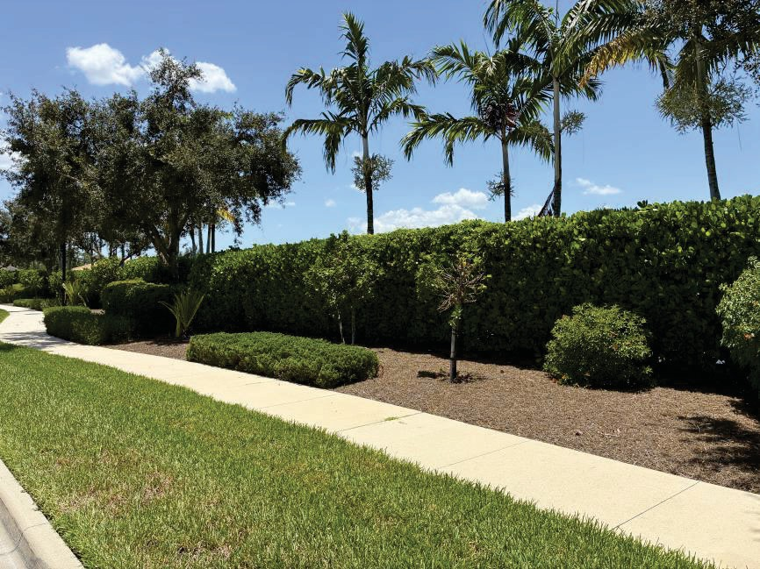
Hedge Line

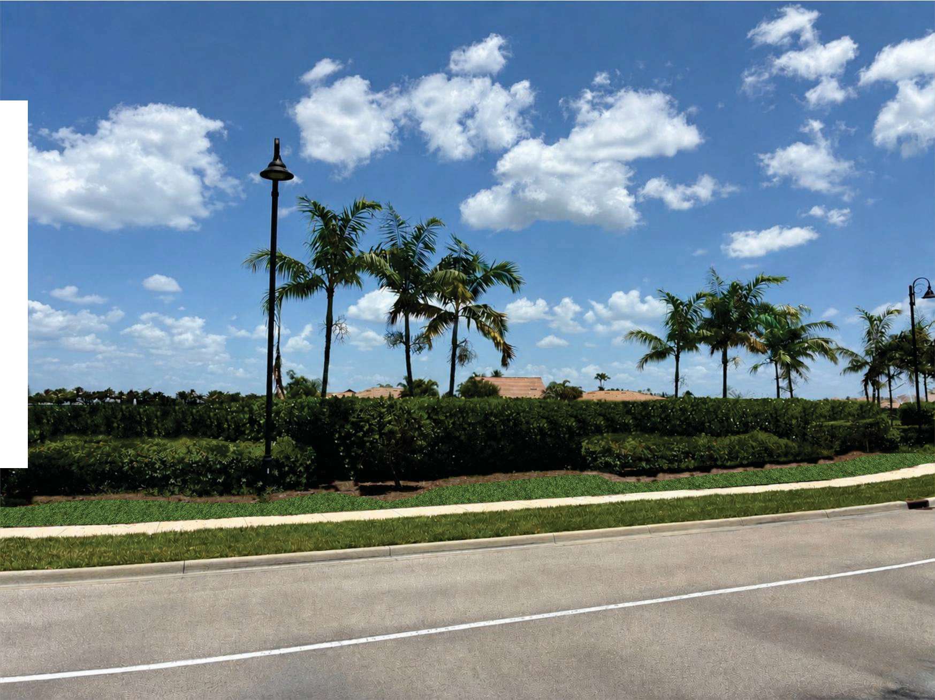

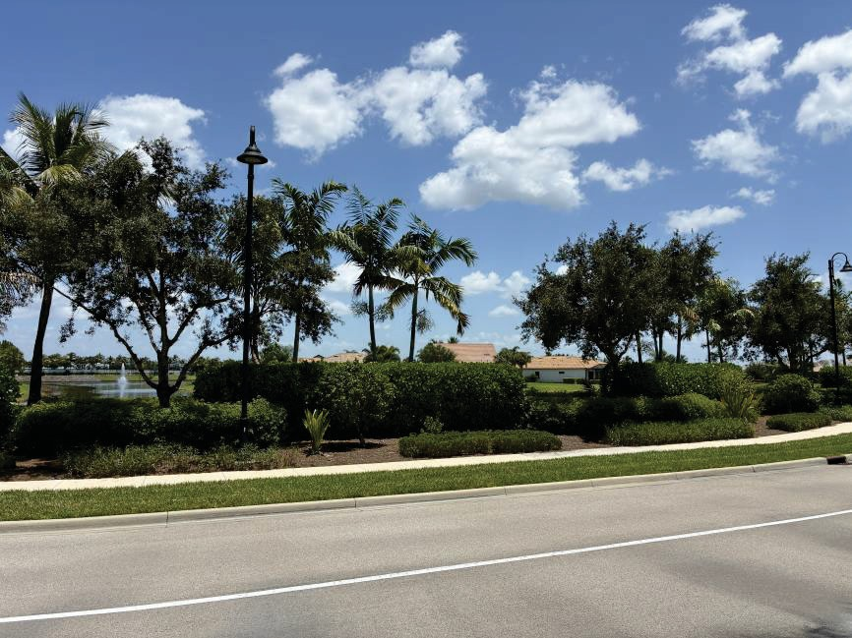
Hedge Line

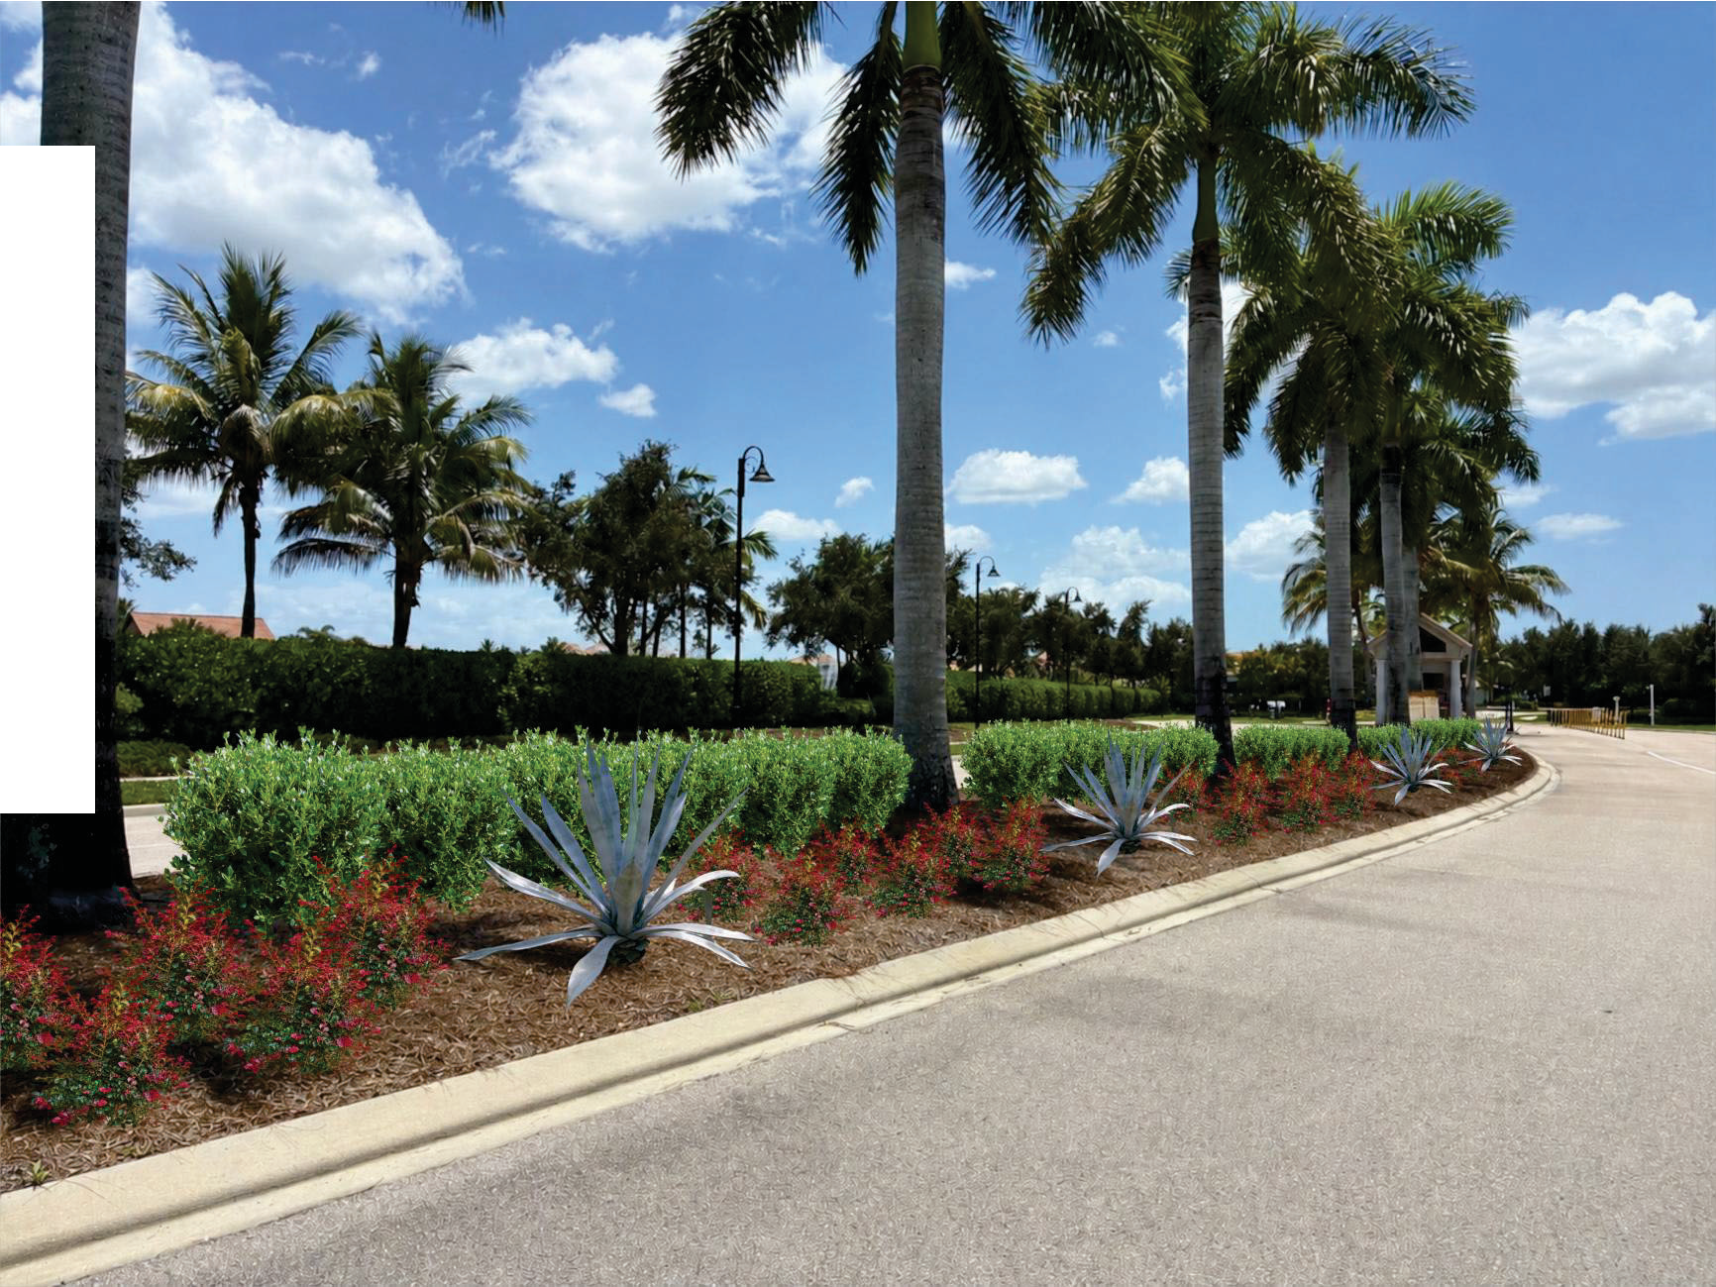

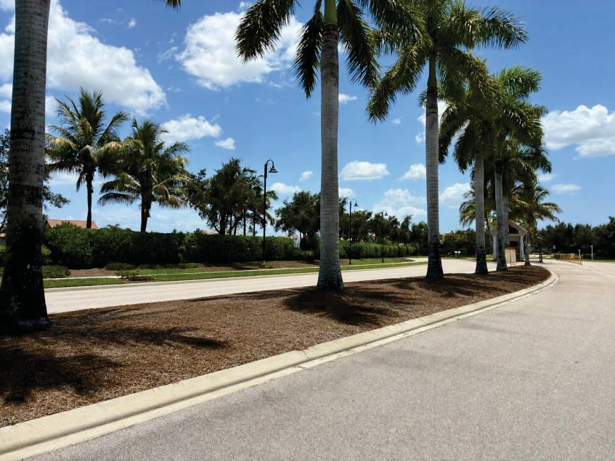
Median

RESOLUTION 2026-06

A RESOLUTION OF THE BOARD OF SUPERVISORS OF THE ARBORWOOD COMMUNITY DEVELOPMENT DISTRICT DECLARING VACANCIES IN SEATS ONE AND THREE OF THE BOARD OF SUPERVISORS PURSUANT TO SECTION 190.006(3)(b), FLORIDA STATUTES; AND PROVIDING FOR SEVERABILITY AND AN EFFECTIVE DATE.

WHEREAS, the Arborwood Community Development District (“District”) is a local unit of special-purpose government created and existing pursuant to Chapter 190, Florida Statutes; and
WHEREAS, on November 3, 2026, three members of the Board of Supervisors (“Board”) were to be elected by the “Qualified Electors” of the District, as that term is defined in Section 190.003, Florida Statutes; and
WHEREAS, the District published a notice of qualifying period set by the Supervisor of Elections at least two (2) weeks prior to the start of said qualifying period; and
WHEREAS, at the close of the qualifying period there were no Qualified Electors qualified to run for seat number one and seat number three, which were both available for election by the Qualified Electors of the District; and
WHEREAS, pursuant to Section 190.006(3)(b), Florida Statutes, the Board shall declare the seats vacant, effective the second Tuesday following the general election; and
WHEREAS, a Qualified Elector is to be appointed to the vacant seats within 90 days thereafter; and
WHEREAS, the Board finds that it is in the best interests of the District to adopt this Resolution declaring the seats available for election as vacant.

NOW, THEREFORE, BE IT RESOLVED BY THE BOARD OF SUPERVISORS OF THE ARBORWOOD COMMUNITY DEVELOPMENT DISTRICT:

DECLARATION OF VACANT BOARD SUPERVISOR SEATS. The
following seats are hereby declared vacant effective as of November 17, 2026: Seat 1 – (currently held by Donald Schrotenboer); and
Seat 3 – (currently held by Jack Aycock);
- INCUMBENT BOARD SUPERVISORS. Until such time as the Board nominates Qualified Electors to fill the vacancies declared in Section 1 above, the incumbent Board Supervisors for Seats 1 and 3 shall remain in office.

- SEVERABILITY. The invalidity or unenforceability of any one or more provisions of this Resolution shall not affect the validity or enforceability of the remaining portions of this Resolution, or any part thereof.
- EFFECTIVE DATE. This Resolution shall become effective upon its passage.
PASSED AND ADOPTED this 18th day of September 2026.

ATTEST: ARBORWOOD COMMUNITY DEVELOPMENT DISTRICT

Assistant Secretary Chairperson, Board of Supervisors

RESOLUTION 2026-07

A RESOLUTION OF THE BOARD OF SUPERVISORS OF THE ARBORWOOD COMMUNITY DEVELOPMENT DISTRICT RESETTING THE PUBLIC HEARING ON THE DISTRICT’S ADOPTION OF RULES OF PROCEDURE; AMENDING RESOLUTION 2026-02 TO SET THE PUBLIC HEARING THEREON; PROVIDING A SEVERABILITY CLAUSE; AND PROVIDING AN EFFECTIVE DATE.

WHEREAS, the Arborwood Community Development District (“District”) is a local unit of special-purpose government created and existing pursuant to Chapter 190, Florida Statutes, as amended, and

WHEREAS, the Board of Supervisors of the District (“Board”) previously adopted Resolution 2026-02, setting the public hearing to consider the District’s adoption of rules of procedure, and set the hearing thereon for August 17, 2026, at 9:00 a.m. at the Amenity Center Community Room, Somerset at the Plantation, 10401 Dartington Drive, Ft. Myers, Florida 33913.

WHEREAS, the Board desires to reset the public hearing to be held on
, 2026 at 9:00 a.m., at the Amenity Center Community Room, Somerset at the Plantation, 10401 Dartington Drive, Ft. Myers, Florida 33913.

NOW, THEREFORE, BE IT RESOLVED BY THE BOARD OF SUPERVISORS OF THE ARBORWOOD COMMUNITY DEVELOPMENT DISTRICT:

SECTION 1. PUBLIC HEARING RESET. Resolution 2026-02 is hereby amended to reflect that the public hearing is reset to , 2026 at 9:00 a.m., at Amenity Center Community Room, Somerset at the Plantation, 10401 Dartington Drive, Ft. Myers, Florida 33913.
SECTION 2. AUTHORIZED TO PUBLISH NOTICE. The District Secretary is directed to publish notice of the hearing in accordance with Section 120.54, Florida Statutes.

SECTION 3. RESOLUTION 2026-02 OTHERWISE REMAINS IN FULL FORCE AND EFFECT.
Except as otherwise provided herein, all of the provisions of Resolution 2026-02 continue in full force and effect.

SECTION 3. SEVERABILITY. The invalidity or unenforceability of any one or more provisions of this Resolution shall not affect the validity or enforceability of the remaining portions of this Resolution, or any part thereof.

SECTION 4. EFFECTIVE DATE. This Resolution shall take effect upon its passage and adoption by the Board.

PASSED AND ADOPTED this 21st day of September, 2026.

ATTEST: ARBORWOOD COMMUNITY

DEVELOPMENT DISTRICT

Secretary/Assistant Secretary Chair/Vice Chair, Board of Supervisors

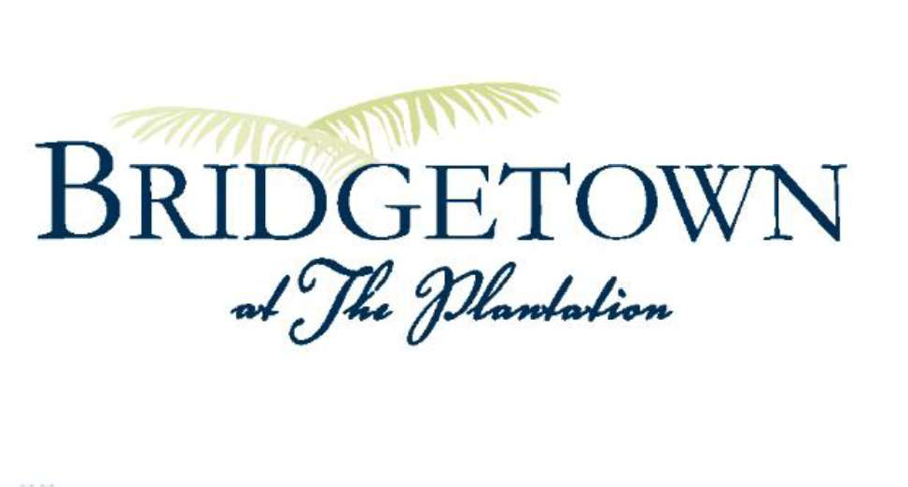

September - 08/31/2026

Lake Water Quality | - All parameters are in reasonable range.
Lake Doctor Monthly Summary | - Lakes were treated for algae/chara  - Lake 18 was treated for significant amount of algae  - Commented on the water levels are at the high mark
Lake Bank Conditions | Copeland Southern Enterprises continues to monitor the water levels to make the remaining repairs to the lake bank.
Preserves | - Signed the next three-year agreement (2027-2030) with Wood & Wetlands  - Signed the next year (2027) agreement with Lake Doctors  - Monthly maintenance  - Quarterly Aeration Maintenance  - Muck level testing
Resident Requests | None
Pool Install Lake Side Since O1/2026 | - I 0887 Rutherford-completed  - 11801 Clifton-completed  - 10910 Stonington-recently approved, work scheduled to be completed by end of September
Other Updates | Storm Drain cleaning will commence 09/02/26.

Arborwood Community Development District

Budget vs. Actual
October 2025 - August 2026

 | Oct 25 - Aug 26 |  | 25/26 Budget |  | $ Over Budget |  | % of Budget
Revenue
O & M Assessments | 539,812.41 |  | 539,884.00 |  | -71.59 |  | 99.99%
Debt Assessments (2018) | 2,632,197.15 |  | 2,633,569.00 |  | -1,371.85 |  | 99.95%
Debt Assessments (2014A-1) | 513,349.80 |  | 513,421.00 |  | -71.20 |  | 99.99%
Debt Assessments (2014A-2) | 52,441.65 |  | 52,459.00 |  | -17.35 |  | 99.97%
Debt Assess-Pd To Trustee-2018 | -2,525,480.85 |  | -2,528,226.00 |  | 2,745.15 |  | 99.89%
Debt Asses-Pd To Trustee-2014A1 | -492,537.45 |  | -492,885.00 |  | 347.55 |  | 99.93%
Debt Asses-Pd To Trustee-2014A2 | -50,315.75 |  | -50,360.00 |  | 44.25 |  | 99.91%
Assessment Fees | -11,715.00 |  | -10,000.00 |  | -1,715.00 |  | 117.15%
Assessment Discounts | -139,825.62 |  | -149,573.00 |  | 9,747.38 |  | 93.48%
Carryover Balance | 0.00 |  | 17,000.00 |  | -17,000.00 |  | 0.0%
Total Income | 517,926.34 |  | 525,289.00 |  | -7,362.66 |  | 98.6%
Expense
Payroll Tax Expense | 642.60 |  | 880.00 |  | -237.40 |  | 73.02%
Supervisor Fees | 8,400.00 |  | 11,000.00 |  | -2,600.00 |  | 76.36%
Engineering | 31,050.64 |  | 50,000.00 |  | -18,949.36 |  | 62.1%
Management Fees | 38,577.00 |  | 42,084.00 |  | -3,507.00 |  | 91.67%
Website Management | 1,833.26 |  | 2,000.00 |  | -166.74 |  | 91.66%
Legal Fees | 6,030.61 |  | 19,000.00 |  | -12,969.39 |  | 31.74%
Assessment/Tax Roll | 0.00 |  | 5,000.00 |  | -5,000.00 |  | 0.0%
Audit Fees | 5,250.00 |  | 5,450.00 |  | -200.00 |  | 96.33%
Arbitrage Rebate Fee | 1,000.00 |  | 1,000.00 |  | 0.00 |  | 100.0%
Amortization Schedule Fee | 0.00 |  | 500.00 |  | -500.00 |  | 0.0%
Insurance | 6,998.00 |  | 13,000.00 |  | -6,002.00 |  | 53.83%
Legal Advertisements | 3,723.56 |  | 5,250.00 |  | -1,526.44 |  | 70.93%
Miscellaneous | 3,376.63 |  | 3,200.00 |  | 176.63 |  | 105.52%
Postage and Delivery | -432.58 |  | 1,125.00 |  | -1,557.58 |  | -38.45%
Office Supplies | 1,817.85 |  | 2,275.00 |  | -457.15 |  | 79.91%
Dues, License & Subscriptions | 175.00 |  | 175.00 |  | 0.00 |  | 100.0%

Arborwood Community Development District

Budget vs. Actual
October 2025 - August 2026

 | Oct 25 - Aug 26 |  | 25/26 Budget |  | $ Over Budget |  | % of Budget
Trustee Fees | 12,738.75 |  | 22,500.00 |  | -9,761.25 |  | 56.62%
Continuing Disclosure Fee | 3,000.00 |  | 3,000.00 |  | 0.00 |  | 100.0%
Professional Fee & Permits | 0.00 |  | 1,250.00 |  | -1,250.00 |  | 0.0%
Treeline Preserve Maint-Exotics | 0.00 |  | 0.00 |  | 0.00 |  | 0.0%
DRI / Traffic Monitoring | 15,300.00 |  | 5,000.00 |  | 10,300.00 |  | 306.0%
Environmentl Consulting-Passarella | 20,908.75 |  | 23,000.00 |  | -2,091.25 |  | 90.91%
Panther Mitigation Mnt-Exotics | 80,000.00 |  | 80,000.00 |  | 0.00 |  | 100.0%
Field Inspector - Somerset Only | 23,004.32 |  | 25,500.00 |  | -2,495.68 |  | 90.21%
Lake Maintenance-Somerset Only | 45,674.86 |  | 50,000.00 |  | -4,325.14 |  | 91.35%
Preserve Maint - Somerset Only | 44,000.00 |  | 37,000.00 |  | 7,000.00 |  | 118.92%
Flowway Maintenance | 0.00 |  | 10,600.00 |  | -10,600.00 |  | 0.0%
Preserve Maint (Parcel C Only) | 0.00 |  | 7,000.00 |  | -7,000.00 |  | 0.0%
Lake Bank Erosion Mte(Somerset) | 0.00 |  | 47,000.00 |  | -47,000.00 |  | 0.0%
Strmwtr Drains Ins/MTE-Somerset | 44,332.50 |  | 30,000.00 |  | 14,332.50 |  | 147.78%
Strmwtr Drains Ins (Bridgetown) | 6,720.00 |  | 6,500.00 |  | 220.00 |  | 103.39%
Lake Bank Inspection-Somerset | 0.00 |  | 7,500.00 |  | -7,500.00 |  | 0.0%
Lake Bank Inspection-Bridgetown | 0.00 |  | 6,500.00 |  | -6,500.00 |  | 0.0%
Miscellaneous Maintenance | 1,700.00 |  | 0.00 |  | 1,700.00 |  | 100.0%
Capital Outlay - Small | 0.00 |  | 1,000.00 |  | -1,000.00 |  | 0.0%
Total Expenditures | 405,821.75 |  | 525,289.00 |  | -119,467.25 |  | 77.26%
Net Revenue | 112,104.59 |  | 0.00 |  | 112,104.59 |  | 100.0%

Bridgetown Balance As Of 10/1/25 | $ 12,640.62
Somerset Balance As Of 10/1/25 | $ 27,275.68

Bridgetown Activity: 10/1/25 - 8/31/26 | $ 6,280.00
Somerset Activity: 10/1/25 - 8/31/26 | $ 39,988.32
Bridgetown Balance As Of 8/31/26 | $ 18,920.62
Somerset Balance As Of 8/31/26 | $ 67,264.00

Arborwood Community Development District

Budget vs. Actual
October 2025 - August 2026

Oct 25 - Aug 26 25/26 Budget $ Over Budget % of Budget

Bank Balance As Of 8/31/26 | $ 663,838.11
Accounts Payable As Of 8/31/26 | $ 22,587.62
Other Assets As Of 8/31/26 | $ -
Total Fund Balance As Of 8/31/26 | $ 641,250.49

Series 2014A-1 Bond Balance As Of 8/31/26 | $ 3,545,000.00
Series 2014A-2 Bond Balance As Of 8/31/26 | $ 400,000.00
Series 2018A-1 Bond Balance As Of 8/31/26 | $ 15,110,000.00
Series 2018A-2 Bond Balance As Of 8/31/26 | $ 5,270,000.00
Total Bond Balance As Of 8/31/26 | $ 24,325,000.00

